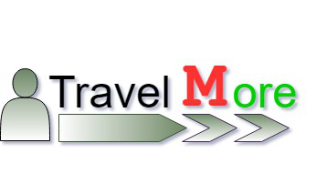

ABSTRACT

As tourism is one of the fastest growing industries today, thus within the tourism industry events are getting more and more important. Nowadays there are many travel packages existing from different websites to almost all the places over the world. A customer finds it very difficult to search for the best package as he/she has to browse multiple websites at the same time, contact many travel agents and etc. To address this issue, we adopt <website name> which offers the best package among all the other packages that are over the net.

This project will suggest the best for the tourist to choose from the varied choices on the website. On multiple demands of tourist that is, a customer will select a travel package for a particular place based on the recommendations provided by the previous customers who had experience with the package. Therefore, according to the personalized recommendations, he/she will choose the best package that is on the website.

Our website shows varied facilities offered to the tourist over a palate. We mainly focus on the tourists perquisites. The website focuses on providing on best of facilities through a clear glass as in where the tourists can go in a flow of choosing their ideal destination through the ideal hotels. The new features of the website stands as the additional feature of traveling through the cruises in and around the country.the cruises are built in first in class with all privileges.

SOFTWARE DEVELOPMENT LIFE CYCLE

* Phase 1: Requirement collection and analysis
* Phase 2: Feasibility study:
* Phase 3: Design:
* Phase 4: Coding:
* Phase 5: Testing:
* Phase 6: Installation/Deployment:
* Phase 7: Maintenance

Problem statement:

* Create a tourism website with new features and new technologies.

Our approaches

* Categorize the means of transport.
* Provide a simple but effective user interface.
* Air different package offers.
* Customers will be awarded with ranges of website usage according to their level of utilization, such as gold member etc.

Additional features

* Travel via cruises in an around the country.
* Get your hands uninfluenced places via the blogs.
* Different travelers come together and share their experiences over a feed or a personal chat.

Other features

* Collaborating with the existing method of payment.
* Collaborating with the local guides.

Flow chart

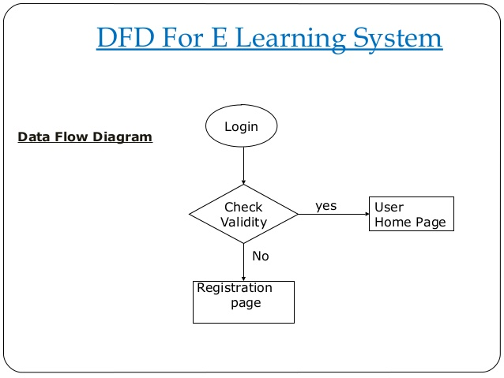

SignIn

SignUp

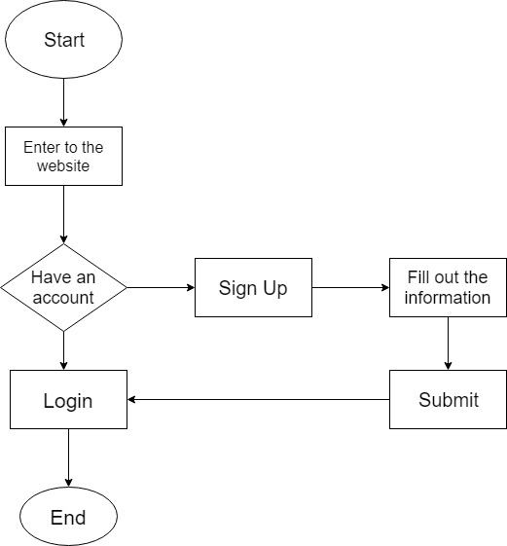

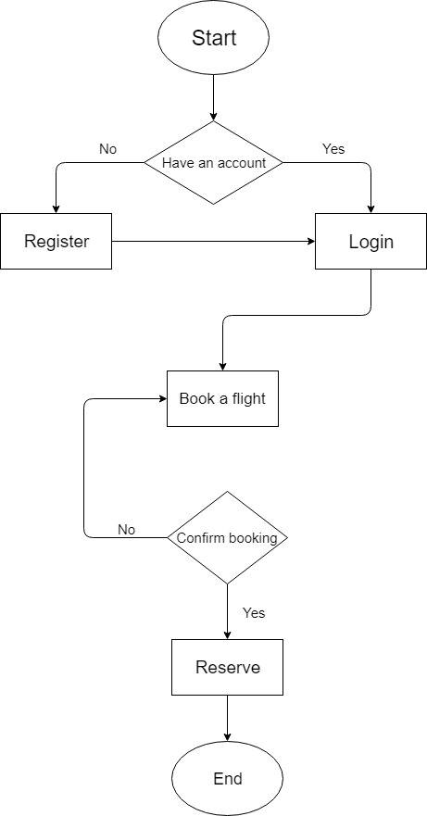Flight

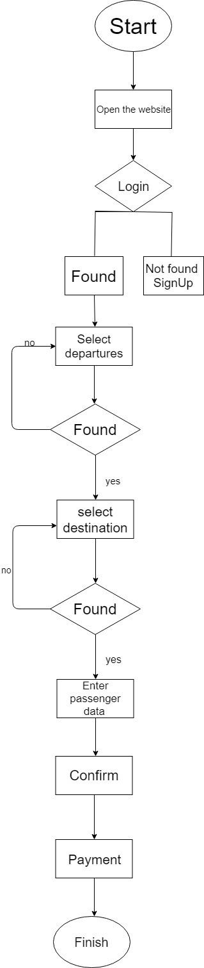Train

Cruise

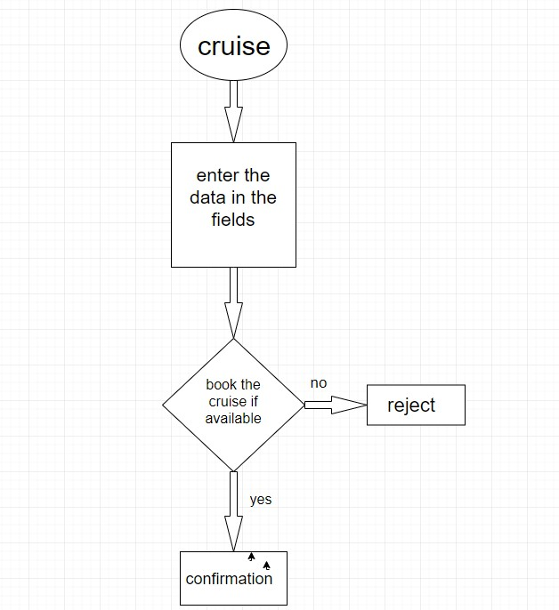

Hotels

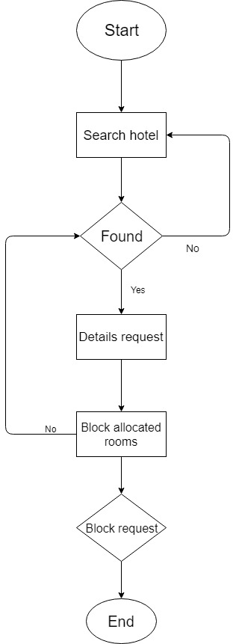

Algorithms

* SignIn:

Step 1-enter the login name and password

Step 2-verify the credentials

If the credentials are verified

Then the access Is granted

Else State that the user doesn’t exist and has to sign up

Step 3-successfully login

* SignUp:

Step 1-when the user enters the credentials they are verified In the DB

Step 2-if the credentials exist

Then SignIn

Else enter the credentials then SignUp

Step 3-submit

* Flight

Step 1-start

Step 2- if account exists

Then SignIn

Else SignUp

Step 3-SignIn/SignUp

Step 4- enter the details required for searching and booking a flight.

Step 5-if booking is available

then confirm

Else book another flight

Step 6-stop

* Train

Step 1-start

Step 2- if account exists

Then SignIn

Else SignUp

Step 3-SignIn/SignUp

Step 4-select departure and destination

Step 5-if the seats are available

then book the tickets

Else search another train

Step 6-stop

* Cruise

Step 1-start

Step 2- if account exists

Then SignIn

Else SignUp

Step 3-SignIn/SignUp

Step 4-select departure and destination

Step 5-if the seats are available

then book the tickets

Else search another Cruise

Step 6-stop

* Hotels

Step 1-start

Step 2- if account exists

Then SignIn

Else SignUp

Step 3-SignIn/SignUp

Step 4-search the desired hotel out of the varied filters

Step 5-if found enter the required details

Else Search for another hotel

Step 6-booking confirmation

Step 7-stop

Site map

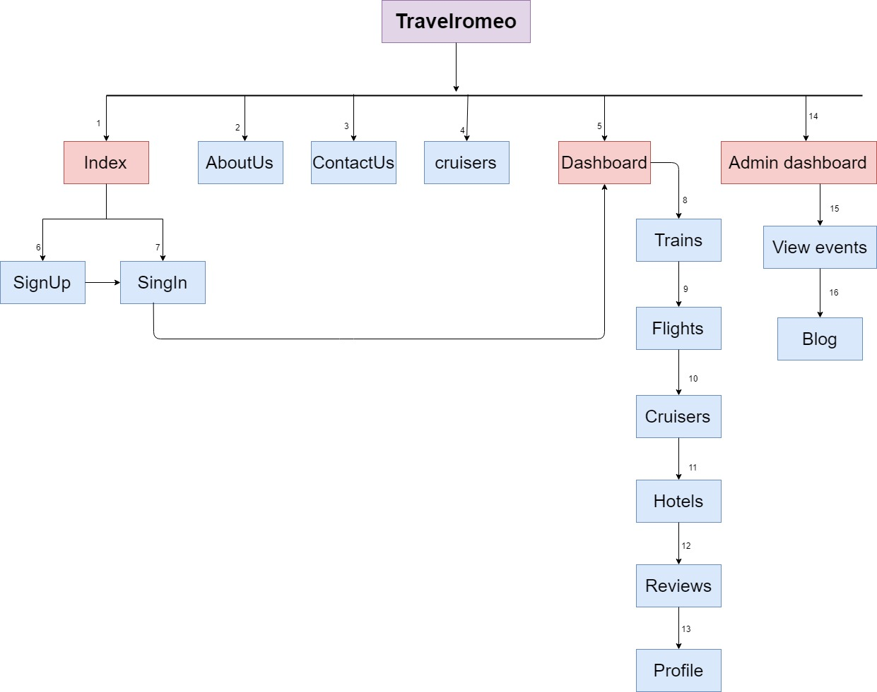

**TravelMore**

